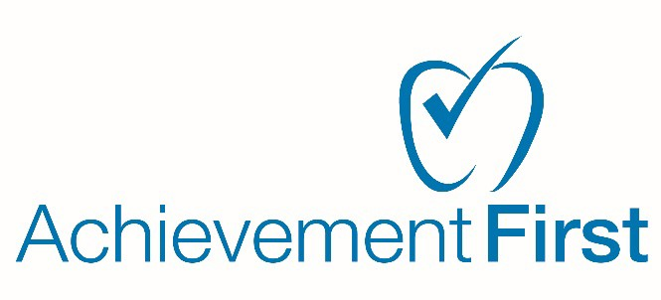

**Notification of Management Plan Availability**

February 28, 2025

To: Parents, guardians, teachers, employees or other personnel From: Achievement First, Inc.

Melinda Rivera

470 James St. Suite 007

New Haven, CT 06513

Dear friends and family,

In a continuing effort to keep our schools safe for all scholars and staff, Achievement First regularly inspects its facilities to ensure that they comply with all federal, state and local regulations. Included in these inspections are periodic observations of all asbestos- containing materials located in the building.

To give you some background about asbestos; in the 1970’s asbestos was commonly used as a building product due to its resistance against fire and chemicals. It is typically found in pipe insulation, fireproofing, and floor tiles. These materials are frequently referred to as Asbestos Containing Building Materials or ACBM. In 1978 the Environmental Protection Agency (EPA) began to regulate such materials and limited their use thereafter. When properly maintained and protected, asbestos- containing materials pose little to no effect on the environment to which it is in.

The Asbestos Hazard Emergency Response Act (AHERA) requires that Achievement First provides you with a notice stating that the following schools have Asbestos Management Plans in place. These Management Plans were prepared and will be monitored by a certified asbestos inspector in the States of Connecticut and Rhode Island. The purpose of these plans is to provide specific information about asbestos previously or currently present in the building, provide procedures that minimize disturbances and provide information about emergency response actions. These Management Plans are available at facilities listed below:

AF Bridgeport Academy Elementary

655 Stillman Avenue, Bridgeport, CT203.338.0593

AF Bridgeport Academy Middle

529 Noble Avenue, Bridgeport, CT 203.333.9128

AF Providence Rhode Island 370 Hartford Avenue, Providence, RI 401.347.1106

AF Envision Elementary School 315 Laurel Hill Avenue, Providence RI 401-633-6261

(includes: AF Providence Mayoral Academy, AF Providence Middle)

In schools which currently contain ACBM, Periodic inspections are conducted every 6 months and Re-inspections every 3 years to ensure that all materials known to contain asbestos are intact and unchanged. If a disturbance is noticed, then, a notification will be posted describing these changes and identifying the response actions that were taken to correct the disturbance.

The Asbestos Management Plans are located in each building’s main office. Feel free to request it for review at any time as we are happy to make it available. If you require additional information or just have general questions or concerns, please feel free to contact me at 203.526.8570 and I will be happy to assist you.

Best regards,

***Melinda Rivera***

Melinda Rivera

Senior Associate, Team Facilities Achievement First, Inc.

470 James St., Suite 007

New Haven, CT 06513