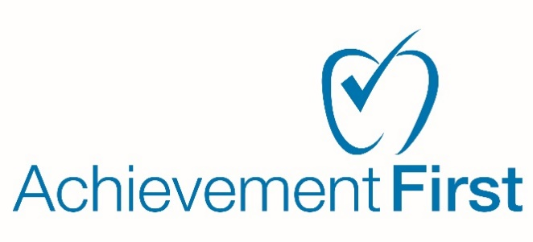

**Indoor Air Quality Inspection Notice**

# December 19, 2024

To: Parents, teachers, employees, other personnel, or their guardians.

From: Achievement First, Inc.

Melinda Rivera

470 James St, Suite 007

New Haven, CT 06513

Dear friends and family,

Achievement First regularly inspects its facilities to ensure they comply with all federal, state, and local regulations. These inspections include yearly Indoor Air Quality inspections.

Inspections are conducted routinely on HVAC systems, ventilation, and air filters to ensure optimal functioning. Our custodial staff utilizes cleaning products that are low-VOC (Volatile Organic compound) to minimize Airbourne pollutants.

We actively monitor any mold growth and address all issues promptly. Including optimizing ventilation systems to circulate air effectively throughout the buildings.

We are committed to continuously improving our IAQ and are currently exploring additional measures to further enhance our air quality management plan for the safety and health of all our scholars and staff.

Please note our inspection dates below for each property:

|  |  |  |  |
| --- | --- | --- | --- |
| Achievement First Bridgeport Academy Elementary | 655 Stillman Ave., Bridgeport, CT | Monday, October 21, 2024 | Yearly Inspection |
| Achievement First Bridgeport Academy Middle | 529 Noble Ave., Bridgeport, CT | Monday, October 21, 2024 | Yearly Inspection |
| Achievement First Elm City College Preparatory | 407 James Street, Bridgeport, CT | Tuesday, October 29, 2024 | Yearly Inspection |
| Achievement First Amistad H School | 580 Dixwell Avenue, Bridgeport, CT | Wednesday, October 23, 2024 | Yearly Inspection |
| Achievement First Amistad K-8 School | 130 Edgewood Avenue, New Haven, CT | Wednesday, October 23, 2024 | Yearly Inspection |
| Achievement First Hartford ES, MS. HS | 305 Greenfield Street, Hartford, CT | Friday, November 8, 2024 | Yearly Inspection |

For more information you can visit the following resources below or contact me directly:

<https://www.epa.gov/indoor-air-quality-iaq>

<https://www.epa.gov/archive/epa/aboutepa/guardian-origins-epa.html>

The link above provides background on conservation, ecology and early environmental movements, the first Earth Day, and the establishment of EPA.

Best regards,

Melinda Rivera

Melinda Rivera

Senior Associate, Team Facilities

203-773-3223 x17603